**Assignment 6**

7.38

7.71

7.90

7.125

7.140

Try solving the assignment in Excel or R for better accuracy rather than manual calculations. But make sure to show which formula you are using for calculation.

**7.38 Potential insurance fraud?**

Insurance adjusters are concerned about the high estimates they are receiving from Jocko’s Garage. To see if the estimates are unreasonably high, each of 10 damaged cars was taken to Jocko’s and to another garage and the estimates (in dollars) were recorded. Results Attached (JOCKO)

(a) For each car, subtract the estimate of the other garage from Jocko’s estimate. Find the mean and the standard deviation for this difference.

(b) Test the null hypothesis that there is no difference between the estimates of the two garages. Be sure to specify the null and alternative hypotheses, the test statistic with degrees of freedom, and the *P*-value. What do you conclude using the 0.05 significance level?

(c) Construct a 95% confidence interval for the difference in estimates.

(d) The insurance company is considering seeking repayment from 1000 claims filed with Jocko’s last year. Using your answer to part (c), what repayment would you recommend the insurance company seek? Explain your answer.

**7.71 Sadness and spending**

The “misery is not miserly” phenomenon refers to a person’s spending judgment going haywire

when the person is sad. In a study, 31 young adults were given $10 and randomly assigned to either a sad or a neutral group. The participants in the sad group watched a video about the death of a boy’s mentor (from *The Champ*), and those in the neutral group watched a video on the Great Barrier Reef.

After the video, each participant was offered the chance to trade $0.50 increments of the $10 for an insulated water bottle.27 Here are the data: **SADNESS**

(a) Examine each group’s prices graphically. Is use of the *t* procedures appropriate for these data? Carefully explain your answer.

(b) Make a table with the sample size, mean, and standard deviation for each of the two groups.

(c) State appropriate null and alternative hypotheses for comparing these two groups.

(d) Perform the significance test at the α = 0.05 level, making sure to report the test statistic, degrees of freedom, and *P*-value. What is your conclusion?

(e) Construct a 95% confidence interval for the mean difference in purchase price between the two groups.

**7.90 Revisiting the sadness and spending study**

In Exercise 7.71 ,the purchase price of a water bottle was analyzed using the two-sample

*t* procedures that do not assume equal standard deviations. Compare the means using a significance test and find the 95% confidence interval for the difference using the pooled methods. How do the results compare with those you obtained in Exercise 7.71? **BPREF**

**7.125 Interracial friendships in college**

A study utilized the random roommate assignment process of a small college to investigate the

interracial mix of friends among students in college.39 As part of this study, the researchers looked at 238 white students who were randomly assigned a roommate in their first year and recorded the proportion of their friends (not including the first-year roommate) who were black. The following table summarizes the results, broken down by roommate race, for the middle of the first and third years of college.

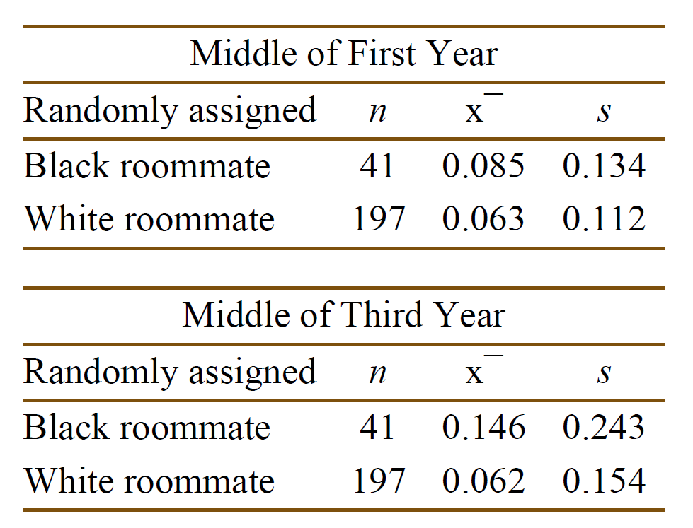

(a) Proportions are not Normally distributed. Explain why it may still be appropriate to use the *t*

procedures for these data.

(b) For each year, state the null and alternative hypotheses for comparing these two groups.

(c) For each year, perform the significance test at the α = 0.05 level, making sure to report the test statistic, degrees of freedom, and *P*-value.

(d) Write a one-paragraph summary of your conclusions from these two tests.

**7.140 Occupation and diet**

Do various occupational groups differ in their diets? A British study of this question compared 98 drivers and 83 conductors of London double-decker buses.48 The conductors’ jobs require more physical activity. The article reporting the study gives the data as “Mean daily consumption (±se).”

Here are some of the study results:

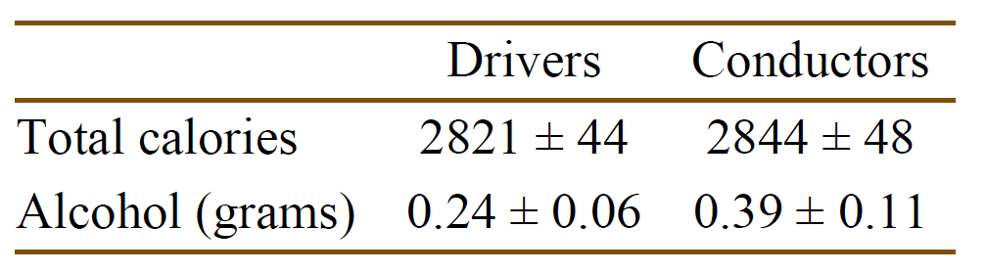

(a) What does “se” stand for? Give x¯ and *s* for each of the four sets of measurements.

(b) Is there significant evidence at the 5% level that conductors consume more calories per day than do drivers? Use the two-sample *t* method to give a *P*-value, and then assess significance.

(c) How significant is the observed difference in mean alcohol consumption? Use two-sample *t*

methods to obtain the *P*-value.

(d) Give a 95% confidence interval for the mean daily alcohol consumption of London double-decker bus conductors.

(e) Give a 99% confidence interval for the difference in mean daily alcohol consumption between

drivers and conductors.